🔐 PortSwigger Lab: File Path Traversal, Traversal Sequences Stripped Non-Recursively
🧪 Lab Overview
Lab Name: File Path Traversal, Traversal Sequences Stripped Non-Recursively
Platform: PortSwigger Web Security Academy
Difficulty: Practitioner
Status: Solved
This lab contains a file path traversal vulnerability in the product image functionality. The application accepts a filename parameter but attempts to remove path traversal sequences such as ../. However, the filtering is performed only once, which makes it possible to bypass the protection and access the /etc/passwd file.

🧠 How I Approached the Problem
I started by accessing a normal product image and observing how the application requested the image file. The request contained a filename parameter with the value 13.jpg.
I intercepted the request using Burp Suite and sent it to Repeater for testing. I first tried different payloads, including an absolute path and a normal relative path traversal payload. When those attempts returned errors, I analyzed the lab description and understood that the application was removing ../ sequences only once.
Based on this behavior, I tested payloads designed to bypass non-recursive filtering. This successfully allowed access to the target file.
📸 Screenshot-by-Screenshot Explanation
📸 Screenshot 1 – Lab Description
The lab description explains that the application is vulnerable to file path traversal through the product image functionality.
The application attempts to remove path traversal sequences from the user-supplied filename. The objective of the lab is to retrieve the contents of the /etc/passwd file.
I clicked Access the Lab to begin testing.
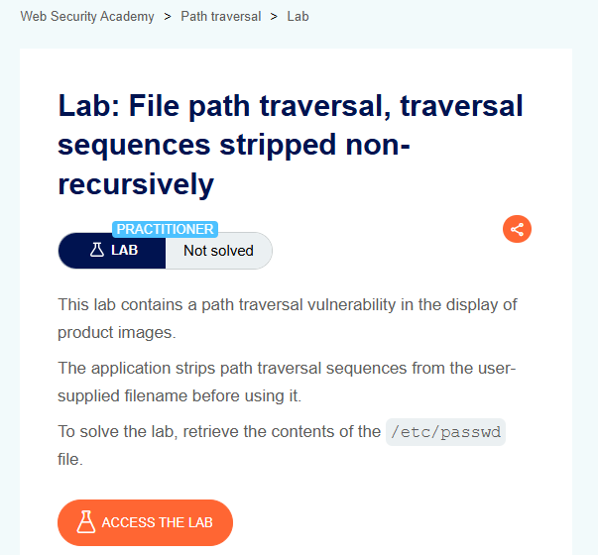
📸 Screenshot 2 – Accessing the Application
After accessing the lab, the application displayed a shopping website with several product images.
Since the vulnerability was related to product images, I selected one of the images and opened it in a new tab to examine how the image was being loaded.

📸 Screenshot 3 – Identifying the Filename Parameter
After opening the image, I observed the URL and found the following parameter:
filename=13.jpg
This showed that the application was using user-controlled input to specify which file should be loaded.
I configured FoxyProxy so that the request could be captured using Burp Suite.
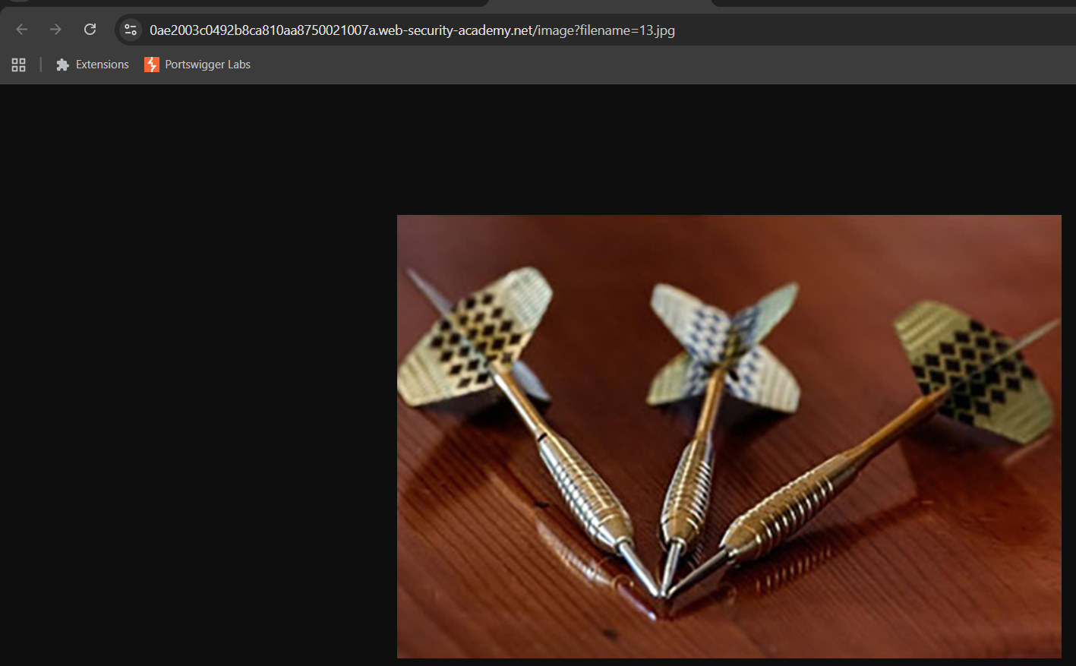
📸 Screenshot 4 – Capturing the Request
I opened Burp Suite and enabled Proxy → Intercept.
Then I returned to the browser and refreshed the page so that Burp Suite could capture the image request.
The captured request showed the filename parameter, which became the main target for testing.
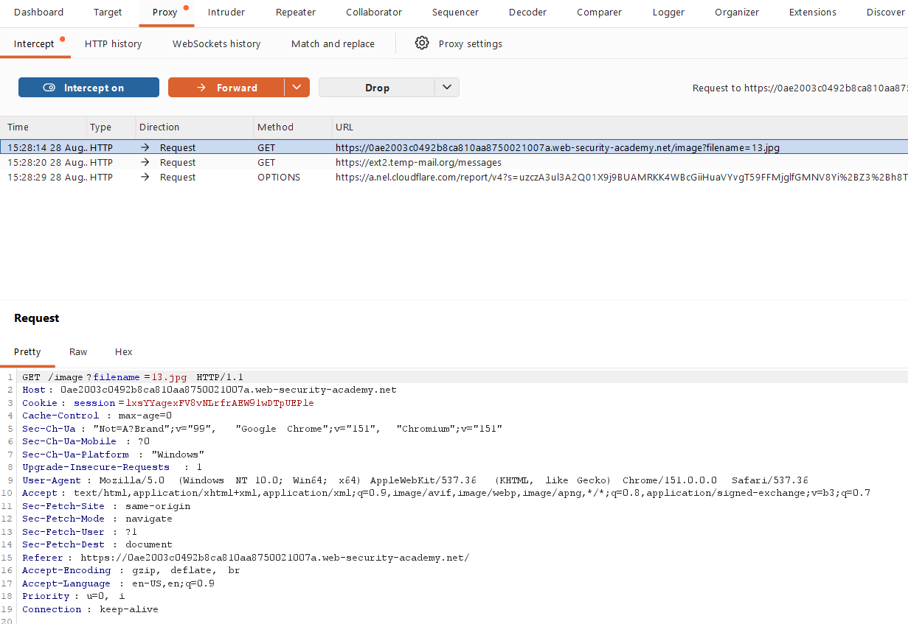
📸 Screenshot 5 – Sending the Request to Repeater
I sent the intercepted request to Burp Repeater for further testing.
First, I sent the original request without modifying anything. The server returned a 200 OK response and successfully displayed the requested image.
This confirmed that the request was working normally before testing different payloads.

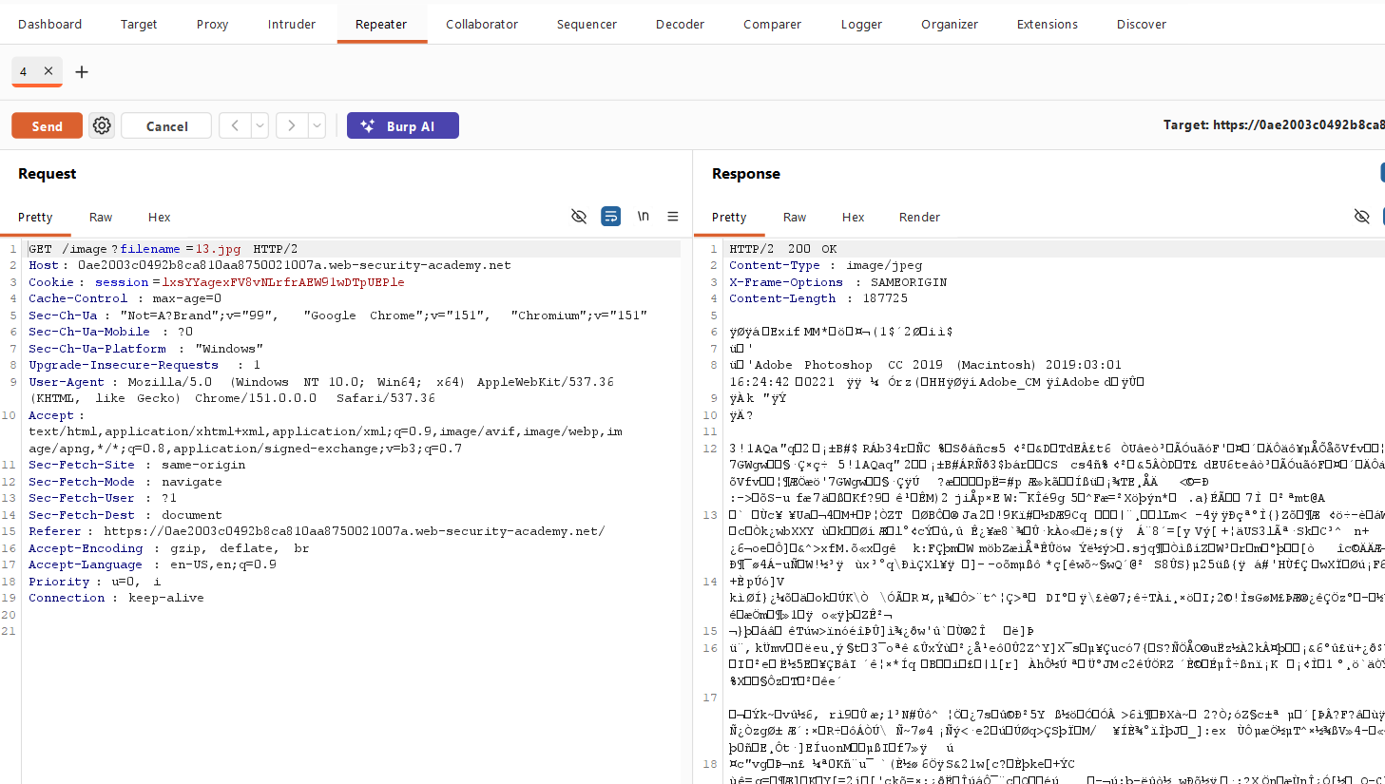
v
📸 Screenshot 6 – Testing an Absolute Path
I first tried using the absolute path:
filename=/etc/passwd
After sending the request, the server returned:
400 Bad Request
"No such file"
This indicated that directly requesting the sensitive file using its absolute path was not successful.
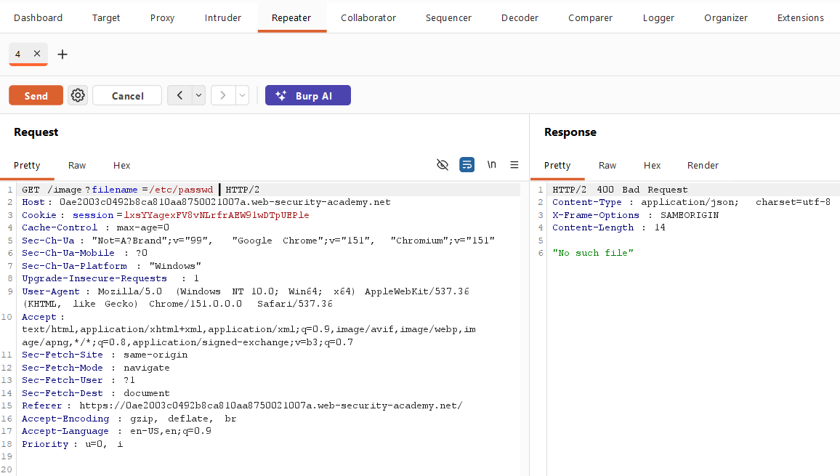
📸 Screenshot 7 – Testing Normal Path Traversal
Next, I tried a standard path traversal payload:
../../../../../../../etc/passwd
After sending the request, the application again returned a 400 Bad Request response.
This suggested that the application was detecting or removing the normal ../ traversal sequences.
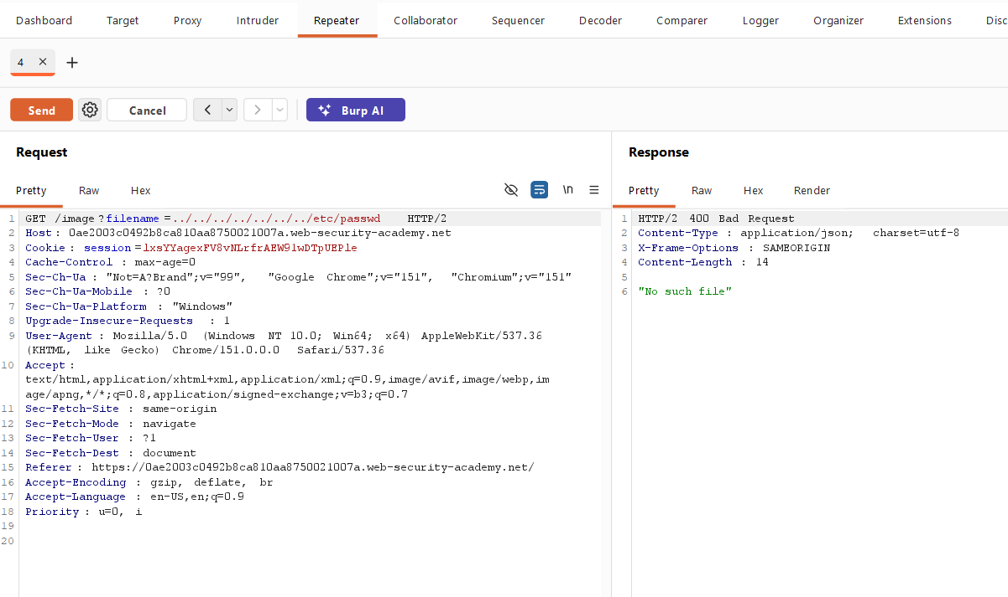
📸 Screenshot 8 – Understanding the Non-Recursive Filter
At this point, I analyzed how the application was filtering the input.
The application tries to remove:
../
However, it performs this removal only once.
For example, an input such as:
....//
can become:
../
after the filtering process.
Because the application does not check the resulting value again, a path traversal sequence can still remain after filtering. This is known as a non-recursive filtering bypass.
I then tested a bypass payload, and the server returned 200 OK with the contents of /etc/passwd. 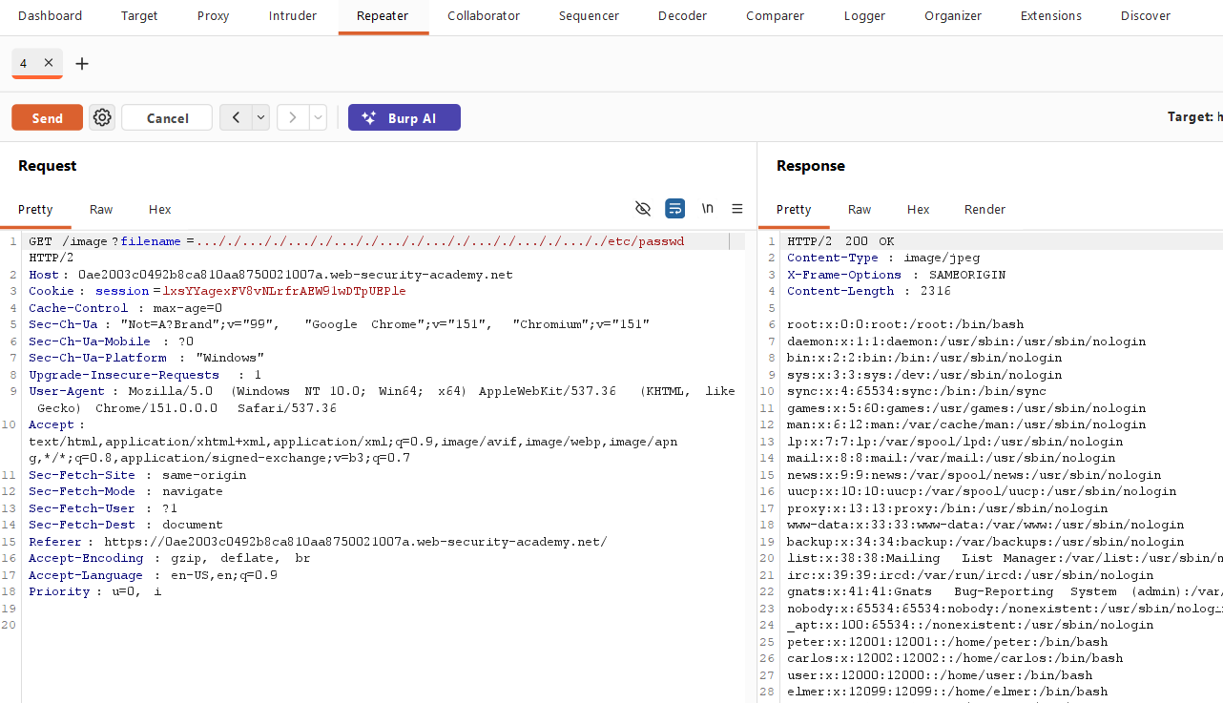
📸 Screenshot 9 – Testing Another Bypass Payload
I also tested the following payload:
....//....//....//....//....//....//....//....//....//etc/passwd
The request successfully bypassed the application's filtering mechanism.
The response returned:
200 OK
and displayed the contents of the /etc/passwd file.
This confirmed the presence of the file path traversal vulnerability.
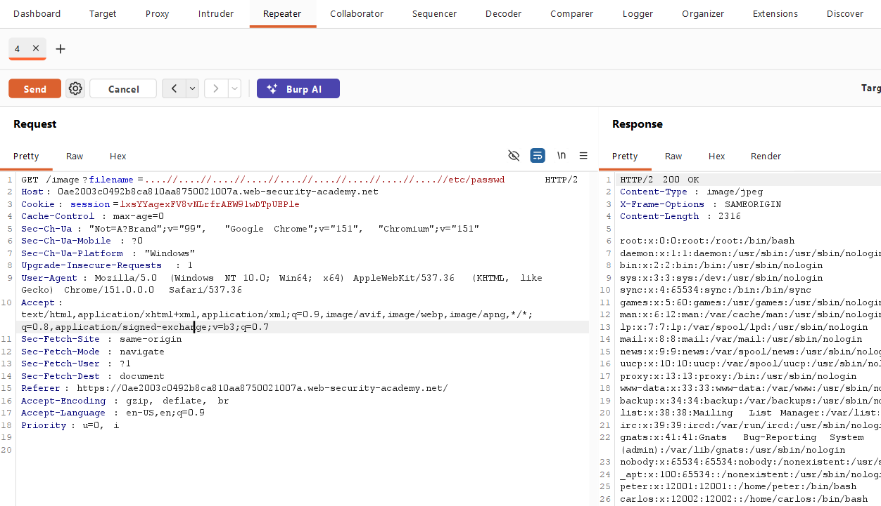
📸 Screenshot 10 – Solving the Lab
Finally, I opened the successful response in the browser.
After accessing the target file through the vulnerable request, the PortSwigger lab displayed the Solved status.
This confirmed that the path traversal vulnerability had been successfully exploited within the authorized lab environment.
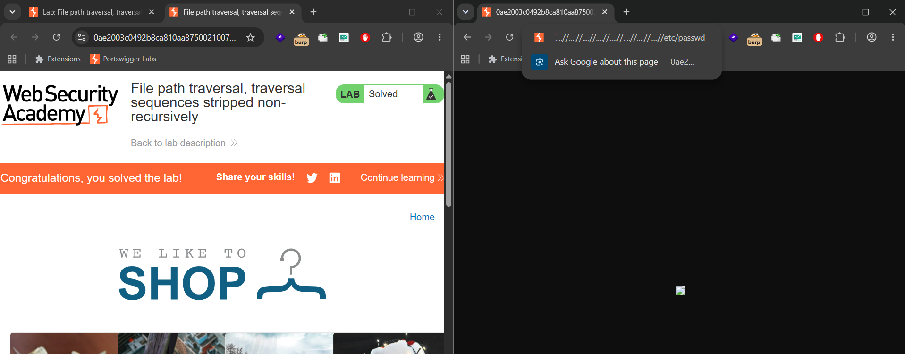
🔍 Different Possibilities I Considered
During testing, I considered multiple possibilities:
- Accessing the file directly using /etc/passwd
- Using normal relative path traversal with ../
- Checking whether the application was filtering traversal sequences
- Testing bypass techniques for non-recursive filtering
- Trying an alternative nested traversal payload
The normal payloads failed, but the bypass payload succeeded because the filtering mechanism removed traversal sequences only once.
⚡ How the Vulnerability Was Confirmed
The vulnerability was confirmed when the modified filename parameter successfully returned:
HTTP/2 200 OK
The response contained the contents of:
/etc/passwd
This proved that user-controlled input could be used to access files outside the intended directory.
🎯 Root Cause
The root cause was improper input sanitization.
The application attempted to protect against path traversal by removing:
../
However, the filtering was performed only once. It did not validate the resulting input again after modification.
Because of this non-recursive filtering, specially crafted input could recreate traversal sequences after the filtering process.
🛡️ Remediation
To prevent this vulnerability:
- Avoid relying on string replacement to remove ../.
- Use an allowlist of valid filenames or file identifiers.
- Normalize and validate the final file path before accessing the file.
- Ensure the resolved path remains inside the intended directory.
- Avoid directly using user-controlled input in file system operations.
📚 Key Learning
This lab demonstrated that simply removing dangerous characters or strings is not always enough to secure an application.
A security filter must consider how the input changes after processing. If validation is incomplete or performed only once, attackers may be able to bypass the protection using specially crafted input.

🎓 My Biggest Takeaway
My biggest takeaway from this lab is:
Never assume that blocked input is completely safe. Understanding how an application processes and filters input is important when testing for vulnerabilities.
A failed payload can also provide useful information about the application's security mechanisms and help identify the correct testing approach.

🏁 Conclusion
This lab demonstrated a file path traversal vulnerability caused by non-recursive filtering.
By analyzing failed attempts, understanding how the application removed ../ sequences, and testing an appropriate bypass payload, I was able to access the /etc/passwd file and successfully solve the lab.
The lab provided practical experience in intercepting requests, modifying parameters, testing payloads, analyzing responses, and understanding weak input sanitization.

🧠 Learning Summary
During this lab, I learned:
- How file path traversal vulnerabilities work.
- How to identify user-controlled file parameters.
- How to capture requests using Burp Suite.
- How to use Burp Repeater for manual testing.
- Why absolute and normal traversal payloads may fail.
- What non-recursive filtering means.
- How insufficient input filtering can lead to security vulnerabilities.
- The importance of validating the final resolved file path.

🔐 Vulnerability Type
File Path Traversal / Directory Traversal
Specific Technique: Traversal sequences stripped non-recursively.
The application attempted to remove path traversal sequences, but because the filtering process was performed only once, specially crafted input was able to bypass the protection.

